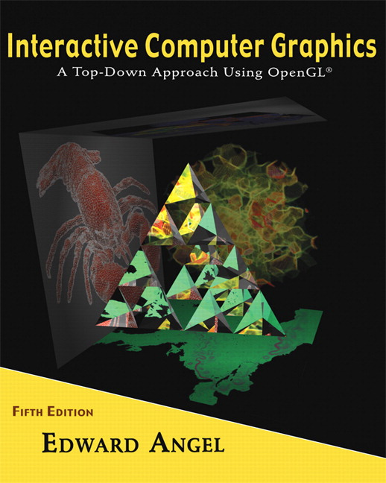

Name: ______________________ Term # ____
Programming Assignment 3
(100 points)

The Programming Assignment is to be turned in the first ten minutes of the due date class as:

Hardcopy (with your terminal #!)
Source Code and screenshots that shows that your Visual Studio 2008 “Programming Assignment 3” PROJECT compiles and runs!

Electronic: Submit the Visual Studio2008 “Programming Assignment 3” zipped PROJECT to BB so you can run it in 200 PGH!

“HOUSE - Summer 2010” Color & Shading and Texturing Instructions
(The file “House Summer 2010.pdf” contains the specifications for the house.)

1. The glutCreateWindow OpenGL call will take as parameter “YourLastName House Version 3”.
2. Start with the MyHouse.c that you have created in Programming Assignment 2 and call the file LastNameHouse.c.

3. Lighting and Shading:
Add 1 spot light initially located on the base inside the house on the front left, distance term a = 1, initial direction towards the top right back of the lower house. You can use the coefficients from the Lecture 6 and the format from Homework 6 for the MaterialStruct.
You should allow the movement of the light source in 3 positions on each x and z axis, i.e., front left, middle, right and side left front, middle, and back.
You should allow three changes of the angle of the light, top, middle, bottom.

4. Texturing:
Texture your house by using either a texture similar to the actual house or any other house siding textures or bump mapping.
If you have several texturing, create a menu to use all of them. I guess this could be the extra credit problem. (10 points)

5. Navigating:
First, the discrete reposition & orientation of the light should be linked to a menu , key, etc.
Second, the LookAt needs to be amended with the following camera positions:

- at the door looking toward the middle back wall, back right top corner, back top left corner - 3.
- in the middle of the house looking at the same as above PLUS back towards the front door. - 4..
Attach these fixed positions to a menu, key, etc.

Get screenshots of the “YourLastName House Version 3” for each view and please comment on what the screenshot is about.

